Final project CSC-17A 42636

Author
Erik Nurja

HANGMAN

INTRODUCTION:
This project consists of the game hangman. This program is a throwback to elementary school times where hangman made learning words fun and frustrating. I chose to do this project because it is a game I am quite familiar with and was easier for me to visualize how the program should execute based on the functionality of the game. It is important because it utilizes arrays and character comparison through the use of classes, which is what object orientation in C++ is centralized around.

HOW TO PLAY:
The game hangman is simple, albeit very difficult depending on the length of the word. The game begins by prompting the user to specify one or two players participating. The player then enters their personal information and begins by choosing a player entered word or a computer generated word from one of the three difficulty tiers. After this is specified, the game begins by displaying the number of characters represented by a field of the same number of dashes displayed below the empty board. The user has the opportunity to make 3, 5, and 7 incorrect guesses respective to easy, normal, and hard mode. The user defined category defaults to 5 incorrect guesses allowed. The user then enters their guess one character at a time either the hangman figure is completed, or the user completes the word, thereby winning the game. Each win is incremented and kept track of for later comparison with the second player for number of wins achieved. At the end of the game, the user is prompted to play again or quit. If they gameplay is repeated (personal information code excluded but retained). If they quit (and are the first player) then execution is passed to player number two and the same game is repeated for them. Upon exiting execution from player two, console displays who accumulated more wins, and then the program terminates.

TOTAL LINES CONTAINED IN SOURCE FILE:
1008

SAMPLE INPUT/OUTPUT
Beginning of program with two players chosen. First and last name entered along with location specification.
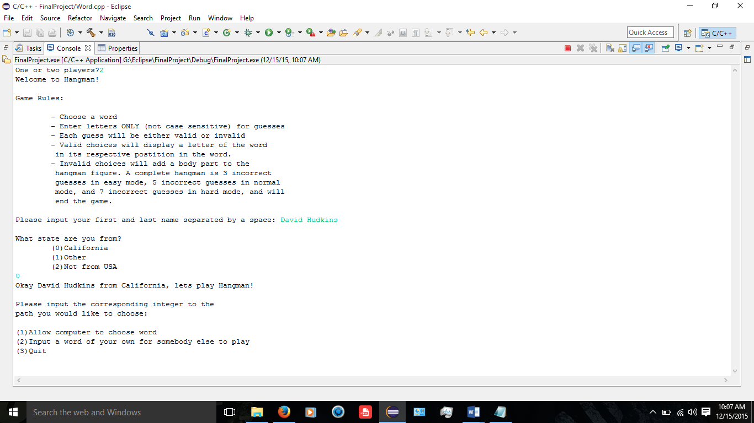

Computer generated word path chosen via integer and gameplay begins by entering characters. Hangman game board is displayed with each turn passed.

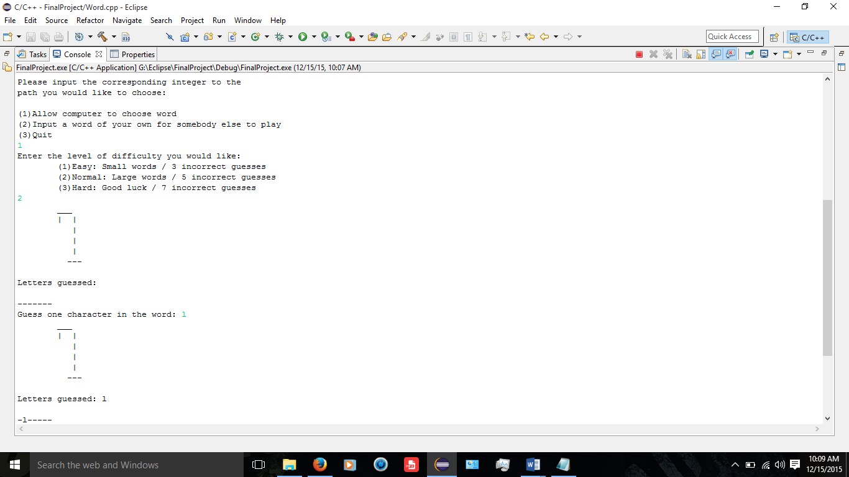
Incorrect guesses made and letter use tracked. Hangman character incremented based on difficulty. Winning condition met and tracked.
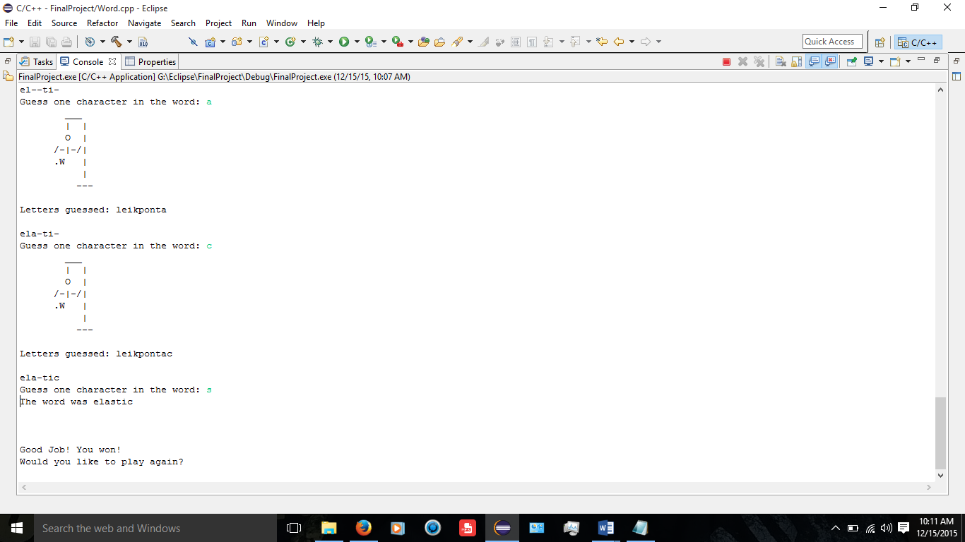

Player 1 chooses not to continue and player 2 begins their gameplay.
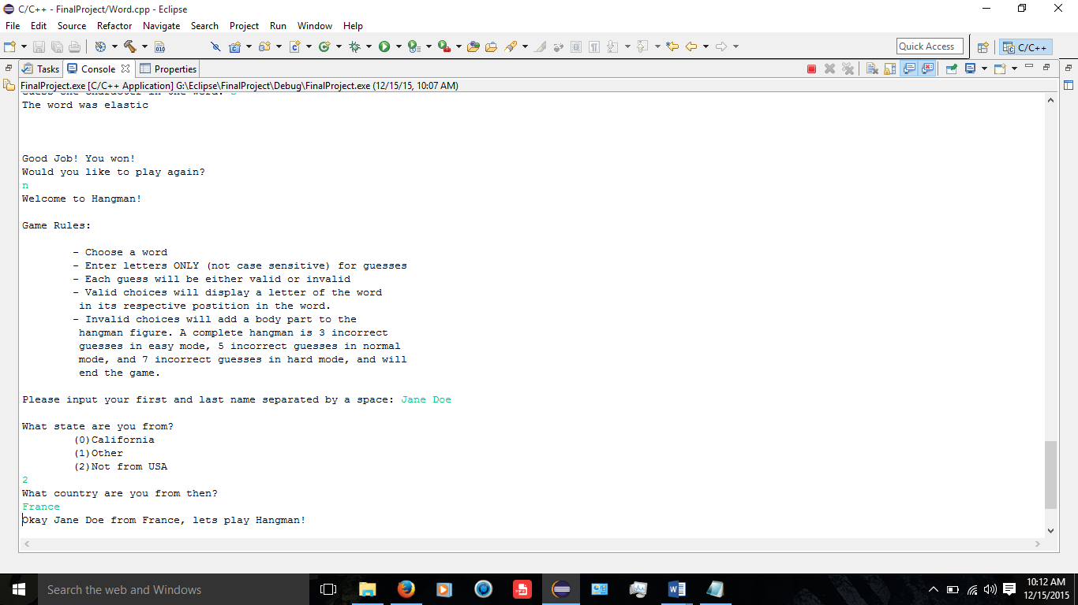
Player two completes hangman figure and console returns that player 1 had more wins.
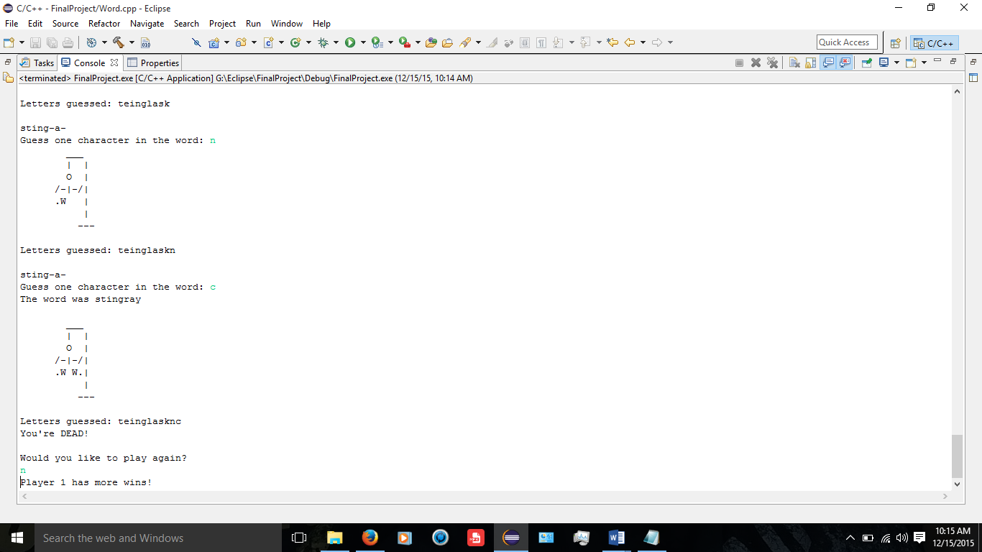

VARIABLES USED:
- int
  - (static const) AR_SIZE
  - diff used in Player class for difficulty setting
  - choice used in Winner class for menu choice
  - path used in Winner class for path choice
  - end used in Winner class for max moves
  - count1 used in Winner class for correct guesses
  - count2 used in Winner class for correct guesses
  - count3 used in Winner class for number of guesses
  - flag used in Winner class for first game phase
  - numWin used in Winner class for number of wins per player
  - chars used in Winner class for number of characters in word
  - incGues used in Winner class for number of guesses made
- Winner
  - p1 used in main for player 1’s class
  - p2 used in main for player 2’s class
- bool
  - win used in Player class for winning condition flag
- string
  - name used in Player class for user name
  - flName1 used in Word class for easy mode word file
  - flName2 used in Word class for normal mode word file
  - flName3 used in Word class for hard mode word file
- char
  - *mark used in Word class for subscript of array guessed correctly
  - *word used in Word class for array of character for game word
  - *prgrss used in Word class for array of correct guesses
  - *guesses used in Word class for array of character guesses
  - quit used in Winner class for choice of continuing game
- ifstream
  - inFile used in Word class for input file designation

REFERENCES:
Textbook: “starting out with C++ >>> From Control Structures through Objects” by Tony Gaddis (8th Edition)

Other than that I googled a few things and looked through stackoverflow.com mostly but no code was copied from anywhere.

SOURCE CODE:
/*
* main.cpp
*
* Created on: May 24, 2017
* Author: Erik Nurja
* Purpose: Execute the game hangman. User chooses either computer generated
* word or the user chooses to input their own word. User then guesses
* letters until word is completely deciphered or fails 6 times and
* the hangman character is completed and the game is over.
*/

//System Libraries

//User Libraries
#include "Winner.h"

//Function Prototypes

//Global Constants

//Program Execution
int main()
{
//Declare Variables
Winner p1;
Winner p2;
int numPs;

//Ask user one or two players
cout<<"One or two players?";
cin>>numPs; //INPUT- number of players

//Validate input
while(!cin >> numPs || numPs<1 || numPs>2) //Execute while input is broken
{
cin.clear(); //Clear keyboard buffer
cin.ignore(1000,'\n'); //Ignore characters until whitespace
cout << "Incorrect input. Please use an integer." << endl << endl; //Inform user of invalid input
cin>>numPs;
}

//Show game rules
p1.rules();

//Get information from user for game initialization
p1.setInfo();

//Play the game
p1.plyGame();

if(numPs==2)
{
//Show game rules
p2.rules();

//Get information from user for game initialization
p2.setInfo();

//Play the game
p2.plyGame();

//Tell users which player had more number of wins in the hangman games
if(p2>p1)
cout<<"Player 2 has more wins!";
else
cout<<"Player 1 has more wins!";
}

return 0; //Terminate Program
}
---------------------------------------------------------------------------------------------------------------------
/*
* Player.h
*
* Created on: May 25, 2017
* Author: Erik Nurja
* Purpose: Create a class Player to keep track of game player's data
* which includes their name and location. This class also handles the
* difficulty level of the game that the user chooses.
*/

#include<iostream> //Console input/output streaming library
#include <string> //Allows use of string class
using namespace std; //Utilize standard namespace

//Structures
enum State {CALIFORNIA, OTHER, NOTINUSA}; //Data type for location

struct PlyInfo //Player information structure
{
string fstName; //Player first name
string lstName; //Player last name
int where; //Player location
};

#ifndef PLAYER_H_
#define PLAYER_H_

class Player
{
protected:
//Variables to be utilized by class Player and derived classes
bool win;
string name;
int diff;
public:
//Default Constructor
Player();

//Accessor Functions
void rules();
int shwMenu();
int getMode(){return diff;}

//Mutator Functions
void setInfo();
void gmMode();

//Destructor
~Player();
};

#endif /* PLAYER_H_ */

---------------------------------------------------------------------------------------------------------------------
/*
* Player.cpp
*
* Created on: May 25, 2017
* Author: Erik Nurja
* Purpose: Define the member functions of the Player class.
*/

#include "Player.h"

#ifndef PLAYER_CPP_
#define PLAYER_CPP_

/******************************************************************************
* Player function is the constructor for the Player class
******************************************************************************/
Player::Player()
{
win = 0;
diff = 0;
name = "0";
}

/******************************************************************************
* rules function accepts no parameters and displays the rules to the
* game Hangman.
******************************************************************************/
void Player::rules()
{
//Display Rules
cout << "Welcome to Hangman!" << endl << endl;
cout << "Game Rules:" << endl << endl;
cout << "\t- Choose a word" << endl;
cout << "\t- Enter letters ONLY (not case sensitive) for guesses" << endl;
cout << "\t- Each guess will be either valid or invalid" << endl;
cout << "\t- Valid choices will display a letter of the word" << endl;
cout << "\t in its respective postition in the word." << endl;
cout << "\t- Invalid choices will add a body part to the " <<endl;
cout << "\t hangman figure. A complete hangman is 3 incorrect" << endl;
cout << "\t guesses in easy mode, 5 incorrect guesses in normal" << endl;
cout << "\t mode, and 7 incorrect guesses in hard mode, and will" << endl;
cout << "\t end the game." << endl << endl;
}

/******************************************************************************
* shwMenu function accepts no parameters and displays the menu for the game
* hangman. The player makes an integer choice through input and the function
* returns that integer to the calling function.
******************************************************************************/
int Player::shwMenu()
{
int choose;
//Display Menu
do
{
//Prompt user to input integer from menu
cout << "Please input the corresponding integer to the" << endl;
cout << "path you would like to choose: " << endl << endl;
cout << "(1)Allow computer to choose word" << endl;
cout << "(2)Input a word of your own for somebody else to play" << endl;
cout << "(3)Quit" << endl;
cin >> choose; //INPUT- Menu choice

//Validate input
while(!cin >> choose) //Execute while input is broken
{
cin.clear(); //Clear keyboard buffer
cin.ignore(1000,'\n'); //Ignore characters until whitespace
cout << "Incorrect input. Please use an integer." << endl << endl; //Inform user of invalid input
cin >> choose;
}
}while(choose != 1 && choose != 2 && choose != 3); //Execute until menu choice is valid

//Return menu choice to calling function
return choose;
}

/******************************************************************************
* getInfo function accepts no parameters and asks user to input information
* including their first and last name, as well as their state of residence.
* It uses a structure PlyInfo to receive the players information. Enumerated
* data type State is used to compare players choice of residence.
******************************************************************************/
void Player::setInfo()
{
PlyInfo Info; //Contains information about the player
string locatn; //Players geographical location

cout << "Please input your first and last name separated by a space: ";
cin >> Info.fstName; //INPUT- User's first name
cin >> Info.lstName; //INPUT- User's last name
cout << "\nWhat state are you from?" << endl;
cout << "\t(0)California" << endl << "\t(1)Other" << endl << "\t(2)Not from USA\n";
cin >> Info.where; //INPUT- User location

//Loop until input is not broken
while(!cin >> Info.where || Info.where > 2 || Info.where < 0)
{
cin.clear(); //Clear keyboard buffer
cin.ignore(1000,'\n'); //Ignore characters until whitespace
cout << "Incorrect input. Please use an integer." << endl << endl; //Inform user of invalid input
cin >> Info.where; //INPUT- User location
}

//Execute if user entered California location
if(Info.where == CALIFORNIA)
locatn = "California"; //Set location to California
//Execute if user entered other location
else if(Info.where == OTHER)
{
//Prompt user to enter their state
cout << "What state are you from then? " << endl;
cin.ignore(1000,'\n'); //Ignore until whitespace
getline(cin,locatn); //INPUT- User location
}
//Execute if user entered out of country
else if(Info.where == NOTINUSA)
{
//Prompt user to enter their country
cout << "What country are you from then?" << endl;
cin.ignore(1000,'\n'); //Ignore until whitespace
getline(cin,locatn); //INPUT- User location
}
//Execute if erroneous input was chosen
else
{
//Prompt user to enter their planet
cout << "If you aren't from the U.S. or any other location on this" << endl;
cout << " planet, then you must be an alien. What planet are you" << endl;
cout << " from, alien scum: " << endl;
cin.ignore(1000,'\n'); //Ignore until whitespace
getline(cin,locatn); //INPUT- User location
}
//Inform user of game start
cout << "Okay " << Info.fstName << " " << Info.lstName << " from ";
cout << locatn << ", lets play Hangman!" << endl << endl;
}

void Player::gmMode()
{
//Display options and prompt user for desired difficulty
cout<<"Enter the level of difficulty you would like: "<<endl;
cout<<"\t(1)Easy: Small words / 3 incorrect guesses"<<endl;
cout<<"\t(2)Normal: Large words / 5 incorrect guesses"<<endl;
cout<<"\t(3)Hard: Good luck / 7 incorrect guesses"<<endl;
cin>>diff; //INPUT- Difficulty level

//Validate input
while(!cin >> diff)
{
cin.clear(); //Clear keyboard buffer
cin.ignore(1000,'\n'); //Ignore characters until whitespace
cout << "Incorrect input. Please use an integer." << endl << endl; //Inform user of invalid input
cin >> diff; //INPUT- Difficulty setting
}
}

/******************************************************************************
* ~Player function is the destructor for the Player class
******************************************************************************/
Player::~Player(){}

#endif /* PLAYER_CPP_ */

---------------------------------------------------------------------------------------------------------------------
/*
* Winner.h
*
* Created on: May 27, 2017
* Author: Erik Nurja
* Purpose: Create Winner class to handle all data regarding the hangman
* game. This class inherits two classes, Player and Word. The class
* uses several character arrays for comparison and contains the actual
* gameplay loop that executes to play and display the game hangman. After
* the game is completed the class destructor is called.
*/

//System Libraries
#include <cstring> //String operator library
#include <iomanip> //Formatting library
#include <stdlib.h> //For exit function
#include <new> //Need for bad_alloc

//User Libraries
#include "Player.h"
#include "Word.h"

#ifndef WINNER_H_
#define WINNER_H_

class Winner : public Player, public Word
{
protected:
//Variables to be utitlized by Winner class and derived classes
int choice; //Menu choice
int path; //Determines how program will execute
int end; //Maximum number of moves
int count1; //Counter for correct guesses
int count2; //Counter for correct guesses
int count3; //Counter for number of guesses
int flag; //Flag for first phase to allow incorrect guess to increment
int numWin; //Holds the number of wins each player gets
string wrdPlay; //Word used to play hangman
char *mark; //Subscript of array already guessed correctly
char *word; //Word used to play hangman
char *prgrss; //Keep track of game progression
char *guesses; //Keep track of alphabetical guesses
int chars; //Number of characters in game word
int incGues; //Number of guesses player has made
char quit; //Choose to continue playing or quit
public:
//Default Constructor
Winner();

//Accessor Functions
int getChoic(){return choice;}
void hangMan();

//Mutator Functions
int initGme(char[], char[]);
void setChoic(int c){choice=c;}
void plyGame();
void play();

//Operator Overloading
bool operator >(const Winner &other);

//Destructor
~Winner();
};

#endif /* WINNER_H_ */

---------------------------------------------------------------------------------------------------------------------
/*
* Winner.cpp
*
* Created on: May 27, 2017
* Author: Erik Nurja
* Purpose: Define member functions of the Winner class
*/

#include "Winner.h"
#ifndef WINNER_CPP_
#define WINNER_CPP_

/******************************************************************************
* Winner function is the constructor for the Winner class
******************************************************************************/
Winner::Winner()
{
choice = 0;
path = 0;
incGues = 0;
count1 = 0;
count2 = 0;
count3 = 0;
flag = 0;
chars = 0;
end = 0;
numWin = 0;
wrdPlay = "0";
quit = '0';

//Verify memory sufficiency
try
{
mark = new char[AR_SIZE];
}
catch(bad_alloc &mark)
{
cout<<"Insufficient memory to allocate";
}

//Verify memory sufficiency
try
{
word = new char[AR_SIZE];
}
catch(bad_alloc &word)
{
cout<<"Insufficient memory to allocate";
}

//Verify memory sufficiency
try
{
prgrss = new char[AR_SIZE];
}
catch(bad_alloc &prgrss)
{
cout<<"Insufficient memory to allocate";
}

//Verify memory sufficiency
try
{
guesses = new char[AR_SIZE];
}
catch(bad_alloc &guesses)
{
cout<<"Insufficient memory to allocate";
}
}

/******************************************************************************
* hangMan function displays the hangman character based on the current
* progression of the game at the time that it is called.
******************************************************************************/
void Winner::hangMan()
{
//Execute according to game difficulty chosen
switch(getMode())
{
//Execute if game is in easy mode
case 1:
//Display initial hangman figure
if(incGues==0)
{
cout<<setw(11)<<"___"<<endl<<setw(12)<<"| |"<<endl<<setw(12)<<"|"<<endl;
cout<<setw(12)<<"|"<<endl<<setw(12)<<"|"<<endl<<setw(13)<<"---"<<endl<<endl;
}

//Display if number of guesses is 1
if(incGues==1)
{
cout<<setw(11)<<"___"<<endl<<setw(12)<<"| |"<<endl<<setw(12)<<" O |";
cout<<endl<<setw(12)<<"|"<<endl<<setw(12)<<"|"<<endl<<setw(12)<<"|";
cout<<endl<<setw(13)<<"---"<<endl<<endl;
}

//Display if number of guesses is 2
else if(incGues==2)
{
cout<<setw(11)<<"___"<<endl<<setw(12)<<"| |"<<endl<<setw(12)<<" O |";
cout<<endl<<setw(12)<<"/-|-/|"<<endl<<setw(12)<<"|"<<endl<<setw(12)<<"|";
cout<<endl<<setw(13)<<"---"<<endl<<endl;
}

//Display if number of guesses is 3
else if(incGues==3)
{
cout<<setw(11)<<"___"<<endl<<setw(12)<<"| |"<<endl<<setw(12)<<" O |";
cout<<endl<<setw(12)<<"/-|-/|"<<endl<<setw(12)<<".W W.|"<<endl<<setw(12)<<"|";
cout<<endl<<setw(13)<<"---"<<endl<<endl;
}
break;

//Execute if game is in normal mode
case 2:
//Display initial hangman figure
if(incGues==0)
{
cout<<setw(11)<<"___"<<endl<<setw(12)<<"| |"<<endl<<setw(12)<<"|"<<endl;
cout<<setw(12)<<"|"<<endl<<setw(12)<<"|"<<endl<<setw(13)<<"---"<<endl<<endl;
}

//Display if number of guesses is 1
if(incGues==1)
{
cout<<setw(11)<<"___"<<endl<<setw(12)<<"| |"<<endl<<setw(12)<<" O |";
cout<<endl<<setw(12)<<"|"<<endl<<setw(12)<<"|"<<endl<<setw(12)<<"|";
cout<<endl<<setw(13)<<"---"<<endl<<endl;
}

//Display if number of guesses is 2
else if(incGues==2)
{
cout<<setw(11)<<"___"<<endl<<setw(12)<<"| |"<<endl<<setw(12)<<" O |";
cout<<endl<<setw(12)<<"/-| |"<<endl<<setw(12)<<"|"<<endl<<setw(12)<<"|";
cout<<endl<<setw(13)<<"---"<<endl<<endl;
}

//Display if number of guesses is 3
else if(incGues==3)
{
cout<<setw(11)<<"___"<<endl<<setw(12)<<"| |"<<endl<<setw(12)<<" O |";
cout<<endl<<setw(12)<<"/-|-/|"<<endl<<setw(12)<<"|"<<endl<<setw(12)<<"|";
cout<<endl<<setw(13)<<"---"<<endl<<endl;
}

//Display if number of guesses is 4
else if(incGues==4)
{
cout<<setw(11)<<"___"<<endl<<setw(12)<<"| |"<<endl<<setw(12)<<" O |";
cout<<endl<<setw(12)<<"/-|-/|"<<endl<<setw(12)<<".W |"<<endl<<setw(12)<<"|";
cout<<endl<<setw(13)<<"---"<<endl<<endl;
}

//Display if number of guesses is 5
else if(incGues==5)
{
cout<<setw(11)<<"___"<<endl<<setw(12)<<"| |"<<endl<<setw(12)<<" O |";
cout<<endl<<setw(12)<<"/-|-/|"<<endl<<setw(12)<<".W W.|"<<endl<<setw(12)<<"|";
cout<<endl<<setw(13)<<"---"<<endl<<endl;
}

break;

//Execute if game is in hard mode
case 3:
//Display initial hangman figure
if(incGues==0)
{
cout<<setw(11)<<"___"<<endl<<setw(12)<<"| |"<<endl<<setw(12)<<"|"<<endl;
cout<<setw(12)<<"|"<<endl<<setw(12)<<"|"<<endl<<setw(13)<<"---"<<endl<<endl;
}

//Display if number of guesses is 1
if(incGues==1)
{
cout<<setw(11)<<"___"<<endl<<setw(12)<<"| |"<<endl<<setw(12)<<" O |";
cout<<endl<<setw(12)<<"|"<<endl<<setw(12)<<"|"<<endl<<setw(12)<<"|";
cout<<endl<<setw(13)<<"---"<<endl<<endl;
}

//Display if number of guesses is 2
else if(incGues==2)
{
cout<<setw(11)<<"___"<<endl<<setw(12)<<"| |"<<endl<<setw(12)<<" O |";
cout<<endl<<setw(12)<<" -| |"<<endl<<setw(12)<<"|"<<endl<<setw(12)<<"|";
cout<<endl<<setw(13)<<"---"<<endl<<endl;
}

//Display if number of guesses is 3
else if(incGues==3)
{
cout<<setw(11)<<"___"<<endl<<setw(12)<<"| |"<<endl<<setw(12)<<" O |";
cout<<endl<<setw(12)<<" -|- |"<<endl<<setw(12)<<"|"<<endl<<setw(12)<<"|";
cout<<endl<<setw(13)<<"---"<<endl<<endl;
}

//Display if number of guesses is 4
else if(incGues==4)
{
cout<<setw(11)<<"___"<<endl<<setw(12)<<"| |"<<endl<<setw(12)<<" O |";
cout<<endl<<setw(12)<<"/-|- |"<<endl<<setw(12)<<"|"<<endl<<setw(12)<<"|";
cout<<endl<<setw(13)<<"---"<<endl<<endl;
}

//Display if number of guesses is 5
else if(incGues==5)
{
cout<<setw(11)<<"___"<<endl<<setw(12)<<"| |"<<endl<<setw(12)<<" O |";
cout<<endl<<setw(12)<<"/-|-/|"<<endl<<setw(12)<<"|"<<endl<<setw(12)<<"|";
cout<<endl<<setw(13)<<"---"<<endl<<endl;
}

//Display if number of guesses is 6
else if(incGues==6)
{
cout<<setw(11)<<"___"<<endl<<setw(12)<<"| |"<<endl<<setw(12)<<" O |";
cout<<endl<<setw(12)<<"/-|-/|"<<endl<<setw(12)<<".W |"<<endl<<setw(12)<<"|";
cout<<endl<<setw(13)<<"---"<<endl<<endl;
}

//Display if number of guesses is 7
else if(incGues==7)
{
cout<<setw(11)<<"___"<<endl<<setw(12)<<"| |"<<endl<<setw(12)<<" O |";
cout<<endl<<setw(12)<<"/-|-/|"<<endl<<setw(12)<<".W W.|"<<endl<<setw(12)<<"|";
cout<<endl<<setw(13)<<"---"<<endl<<endl;
}

break;

//Default switch execution
default: cout<<"ERROR";
}
}

/******************************************************************************
* initGme function intitializes the arrays that are used in the execution of
* the main gameplay. Two character arrays are accepted as parameters and the
* array representing gameplay progress is initialized to the number of
* characters in the gameplay word and then is initialized to blank spaces
* representing their respective characters in their respective location in
* the word. The function then returns the number of characters that are
* contained in the gameplay word to the calling function.
******************************************************************************/
int Winner::initGme(char word[], char progrss[])
{
//Declare variables
int numChar = 0; //Number of characters in gameplay word

//Loop until null terminator is encountered
for(int i=0; word[i]!='\0'; i++)
numChar = i; //Assign number of characters in gameplay word to variable

//Loop for number of characters in gameplay word
for(int i=0; i<=numChar; i++)
progrss[i] = word[i]; //Assign subscript of gameplay word array to subscript of progress array

//Loop for number of characters in gameplay word
for(int i=0; i<=numChar; i++)
progrss[i] = '-'; //Assign blank space to all subscripts of progress array

return numChar; //Return number of characters in gameplay word
}

/******************************************************************************
* plyGame function initializes the array that marks correct guess progression
* at the beginning of a do-while loop. The menu choice is then displayed and
* value chosen passed to the setChoic function. Paths are then executed based
* said menu choice. The user can choose computer generated words, input their
* own, or quit. If computer generated is chosen there are three difficulties
* to choose from and the code will execute accordingly. The winning flag is
* initialized to false and then the game begins. In the nested do-while loop
* the play function is called to allow the player to input a guess. Then an if
* loop is called to check for a correct guess. If so then an incorrect guess
* is not counted and the player is allowed another guess. When the player gets
* the word right, the win flag is set to true and the do-while loop terminates.
* It also terminates if the user exceeds the maximum number of incorrect
* guesses. When the loop terminates the user is asked if they would like to
* continue. If yes the loop is repeated, if not the program is terminated.
*
******************************************************************************/
void Winner::plyGame()
{
do
{
//Initialize array that tracks user progression and correct guesses
for(int i = 0;i<AR_SIZE;i++)
mark[i]='0';

//Display menu and allow user to choose gameplay settings
setChoic(shwMenu());

//Execute according to user's menu choice
switch(choice)
{
case 1: path = 1; //Computer generate word to play
break;

case 2: path = 2; //User input word to play
break;

case 3: cout << "Goodbye!";
exit(choice); //Terminate Program
}

//Computer generates word to play game
if(path == 1)
{
gmMode(); //Set difficulty
wrdPlay = genWord(getMode()); //Set game word to computer generated word

//Set number of incorrect guesses relevant to difficulty chosen
switch(getMode())
{
case 1:
end=3; //Easy mode-3 incorrect guesses allowed
break;

case 2:
end=5; //Normal mode-5 incorrect guesses allowed
break;

case 3:
end=7; //Hard mode-7 incorrect guesses allowed
break;
}
}
else
{
wrdPlay = usrWord(); //Set game word to user input word
end=5; //User mode automatically set to normal
}

strcpy(word,wrdPlay.c_str()); //Convert string to character array

chars = initGme(word,prgrss); //Number of characters in the game word

win = false; //Initialize flag for win to false

//Loop for turns in game
do
{
//Call function to allow player to input character guess
play();

//Loop to check for winning condition
for(int i=0, chkWin=0; i<=chars; i++)
{
if(word[i]==prgrss[i]) //Execute if guess matches a character in the word
{
chkWin+=1; //Increment amount of letters guessed correctly

//Execute if location of score keeping is empty, indicating a new correct guess
if(mark[i]=='0')
{
mark[i]=word[i]; //Input and track correct guess
count1++; //Increment count to indicate correct guess this phase
flag=1; //Set flag to indicate at least one correct guess has been made
}
}

//Execute if number of correct guesses equals number of characters in the game word
if(chkWin==chars+1)
win=true; //Set winning flag to true
}

//Execute if current counter and holding counter evaluate as equal
if(count1 == count2 || flag==0)
incGues++; //Increment number of guesses

//Set counter for number of guesses to current counter for later comparison
count2 = count1;
}while(incGues < end && win==false); //Loop until max guesses or winning condition

//Inform user of what the game word was
cout << "The word was ";

//Loop to display game word
for(int i=0; i<=chars; i++)
cout << word[i];
cout<<endl<<endl;

//Execute if win flag is true
if(win==true)
{
cout << "\n\nGood Job! You won!" << endl; //Inform user of win
numWin+=1;
}

//Execute if win flag is false
if(win==false)
{
//Show completed hangman
cout<<setw(11)<<"___"<<endl<<setw(12)<<"| |"<<endl<<setw(12)<<" O |";
cout<<endl<<setw(12)<<"/-|-/|"<<endl<<setw(12)<<".W W.|"<<endl<<setw(12)<<"|";
cout<<endl<<setw(13)<<"---"<<endl<<endl;
cout<<"Letters guessed: ";

//Show the letters already guessed
for(int i=0; i<count3; i++)
cout<<guesses[i];

//Indicate loss
cout<<"\nYou're DEAD!"<<endl<<endl;
}
//Prompt user to play again
cout << "Would you like to play again?" << endl;
cin >> quit; //INPUT- Play again or not

//Set guesses to 0 and counter for guesses to 0
incGues=0;
count3=0;

}while(quit=='Y' || quit=='y'); //Loop until user chooses to quit
}

/******************************************************************************
* play function deals with arrays that are the gameplay word array and the
* gameplay progress array. The number of characters in the gameplay word is
* handled as well. The function loops to display the progress and prompts the
* user to input one character as a guess regarding the existence of the guess
* as a character in the word. If the guess is correct, it is assigned to
* its respective location in the progress array in as many places as it occurs.
******************************************************************************/
void Winner::play()
{
//Declare variables
char gChar; //INPUT- Character guess

//Show hangman progression
hangMan();
cout<<"Letters guessed: ";

//Show the letters already guessed
for(int i=0; i<count3; i++)
cout<<guesses[i];
cout<<endl<<endl;

//Loop for number of characters in gameplay word
for(int i=0; i<=chars; i++)
cout << prgrss[i]; //Display gameplay progress

//Prompt user to input guess
cout << endl << "Guess one character in the word: ";
cin >> gChar; //INPUT- Character guess

//Put guess in array of guesses
guesses[count3]=gChar;

//Loop for number of characters in gameplay word
for(int i=0; i<=chars; i++)
{
//Execute if guess is correct at gameplay word subscript
if(gChar == word[i])
prgrss[i] = gChar; //Assign guess to progress arrays respective location(s)
}

//Increment number of turns
count3+=1;
}

/******************************************************************************
* This function overloads the greater than operator to compare the number of
* wins that each player had and returns which player has a greater number of
* wins.
******************************************************************************/
bool Winner::operator >(const Winner &other)
{
if(numWin > other.numWin)
return true;
else
return false;
}

/******************************************************************************
* ~Winner function is the destructor for the Winner class
******************************************************************************/
Winner::~Winner()
{
//Delete all dynamically allocated memory in the class
delete[] mark;
delete[] word;
delete[] prgrss;
delete[] guesses;
}

#endif /* WINNER_CPP_ */

---------------------------------------------------------------------------------------------------------------------
/*
* Word.h
*
* Created on: May 26, 2017
* Author: Erik Nurja
* Purpose: Create class word to handle data the hangman program
* uses regarding the word used to play the game.
*/

#include<iostream> //Console input & output
#include<string> //Allows use of string class
#include<fstream> //File operations library
#include<ctime> //Time library
#include<cstdlib> //C-standard library
using namespace std;

#ifndef WORD_H_
#define WORD_H_

class Word
{
protected:
static const int AR_SIZE = 100; //Size of array
ifstream inFile; //Input file designator
string flName1; //Input file name for easy
string flName2; //Input file name for normal
string flName3; //Input file name for hard
public:
//Default Constructor
Word();

//Accessor Functions
string genWord(int);
string usrWord();

//Destructors
~Word();
};

#endif /* WORD_H_ */

---------------------------------------------------------------------------------------------------------------------
/*
* Word.cpp
*
* Created on: May 26, 2017
* Author: Erik Nurja
* Purpose: Define member functions of class Word
*/

//User Libraries
#include "Word.h"

#ifndef WORD_CPP_
#define WORD_CPP_

/******************************************************************************
* Word function is the constructor for the Word class
******************************************************************************/
Word::Word()
{
flName1="0";
flName1="0";
flName3="0";
}

/******************************************************************************
* genWord function accepts two parameters that are a string array and
* the size of that array. The function then assigns words from a file
* to that array to be randomly seeded into a string variable that is passed
* back into the calling function.
******************************************************************************/
string Word::genWord(int difclty)
{
string gameWrd[AR_SIZE]; //Array of words
int index = 0; //Index for array
flName1 = "word1.txt"; //Input file name
flName2 = "word2.txt"; //Input file name
flName3 = "word3.txt"; //Input file name

switch(difclty)
{
case 1:
//Open the word list file and assign words to array
inFile.open(flName1.c_str()); //open file

//Execute until end of file or until max array size
while(!inFile.eof() && (index < AR_SIZE))
{
getline(inFile, gameWrd[index]);//Assign word to array
index++; //Increment array index
}
inFile.close(); //close file

//Seed the random number generator according to time
srand(time(0));

//Return a random word from the word list file
return gameWrd[(rand() % 10)];

case 2:
//Open the word list file and assign words to array
inFile.open(flName2.c_str()); //open file

//Execute until end of file or until max array size
while(!inFile.eof() && (index < AR_SIZE))
{
getline(inFile, gameWrd[index]);//Assign word to array
index++; //Increment array index
}
inFile.close(); //close file

//Seed the random number generator according to time
srand(time(0));

//Return a random word from the word list file
return gameWrd[(rand() % 10)];

case 3:
//Open the word list file and assign words to array
inFile.open(flName3.c_str()); //open file

//Execute until end of file or until max array size
while(!inFile.eof() && (index < AR_SIZE))
{
getline(inFile, gameWrd[index]);//Assign word to array
index++; //Increment array index
}
inFile.close(); //close file

//Seed the random number generator according to time
srand(time(0));

//Return a random word from the word list file
return gameWrd[(rand() % 10)];
}
return 0;
}

/******************************************************************************
* usrWord function accepts no parameters and allows the user to input their
* own word for the hangman program that is no longer than 30 characters.
******************************************************************************/
string Word::usrWord()
{
//Declare variables
string word; //INPUT- User defined word for gameplay

//Prompt user to input game word
cout << "Please enter the word you would like to use to play hangman";
cout << " of no longer than 10 characters: " << endl;
cin >> word; //INPUT- User defined word for gameplay

return word; //Return user defined word for gameplay to calling function
}

/******************************************************************************
* ~Word function is the destructor for the Word class
******************************************************************************/
Word::~Word(){}

#endif /* WORD_CPP_ */

---------------------------------------------------------------------------------------------------------------------

